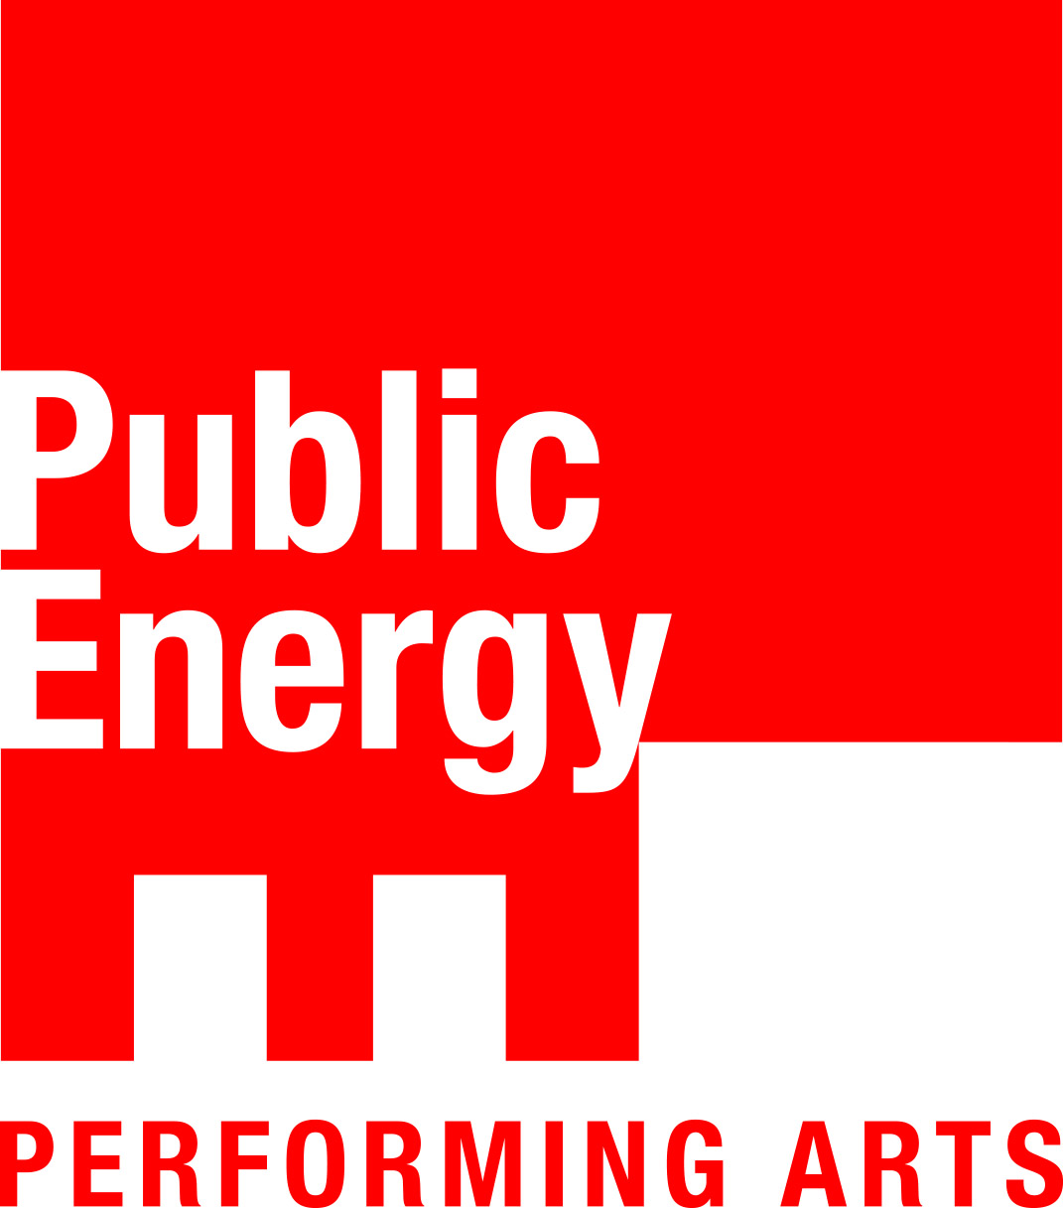 Public Energy Performing Arts

Public Energy Performing Arts presents
The Chemical Valley Project from Broadleaf Theatre (Toronto)
Friday, March 6, at 12:30pm and 7:30pm
Market Hall Performing Arts Centre, 140 Charlotte Street, Peterborough
Tickets available at the Market Hall Box Office online or phone: 705-749-1146

Multi-media storytelling and small scale spectacle combine to make a compelling tale of reconciliation and environmental activism in Canada.

Special Emphasis on Accessibility:
Entire performance will feature American Sign Language (ASL) interpretation and will be presented as a Relaxed Performance with enhanced accessibility features*

Devised Theatre Making and Digital Media workshops
being offered to local artists by Broadleaf Theatre**

The highly acclaimed theatre performance, Chemical Valley Project, is coming to Peterborough for two shows on March 6 at the Market Hall Performing Arts Centre. This award-winning show about environmental activism is presented in a documentary-theatre style by Toronto-based Broadleaf Theatre. Broadleaf Theatre has a national reputation for its multidisciplinary performances about global environmental issues, making little-known topics entertaining and accessible. Accessibility will be emphasized at its Market Hall shows, with two ASL interpreters performing during the show, and ASL interpretation available at the box office.
"The Chemical Valley Project is moving and disruptive theatre, a call to action beautifully told and executed, and a must see for any modern Canadian." – ArtSmarts Monday Magazine (Victoria, B.C.)

40% of Canada's petrochemical industry is packed into 15 square miles in Sarnia, Ontario, called The Chemical Valley. The pollution from the valley has brutal impacts on the surrounding communities and environment, and this is particularly true for the Aamjiwnaang First Nation and its 900 residents. One statistic is especially alarming: Over a 4-year period, the birth rates of boys to girls was roughly 33% boys, and 67% girls, making Aamjiwnaang the first community in the world to have a birth rate of two girls to every boy. Aamjiwnaang residents Vanessa Gray and Beze Gray have dedicated their lives to fighting this environmental racism and to protecting their community’s land, air and water.

Theatre makers Julia Howman and Kevin Matthew Wong have documented their vital activism as land defenders and water protectors and collaborated on the creation of The Chemical Valley Project. Wong is the performer in this solo show and Howman has created the imaginative production design, featuring extensive video shot on location. The Chemical Valley Project engages audiences with its breathtaking blend of documentary-theatre, innovative projection design, a charismatic script and playful solo-performance. This urgent production delves gracefully into difficult conversations on Indigenous treaty rights and the nature of contemporary Canadian identity and values. The Chemical Valley Project has had much critical and popular success since it was first performed in 2017, when it was the NOW Magazine Critics’ Pick at the 2017 SummerWorks Performance Festival. The performance toured across Canada and to Germany in 2018 and premiered at Toronto’s Theatre Passe Muraille in 2019.
Tickets to The Chemical Valley Project cost $25 for general admission, $12 for underwaged, $7 for high school students. Public Energy Performing Arts’ special Underwaged tickets are for those who are not in a position financially to purchase a ticket at full price and this is preventing them from attending an event. In the past it was just students and seniors who could take advantage of reduced ticket prices, but Public Energy offers this as an option for all.

*Relaxed performances use subdued sound and lighting effects. Audiences are also permitted to stand, enter and exit, and make noise during the performance. Relaxed Performances are designed to make theatre spaces more comfortable and welcoming to audience members with autism spectrum disorders, sensory and communication disorders or learning disabilities. Other audience members who benefit from Relaxed Performances include parents with toddlers, people with Tourette’s syndrome, people who experience anxiety or people who are not comfortable with the conventions of a traditional theatre setting.
The Chemical Valley Project Relaxed Performances will also include:
-Two ASL interpreters will be signing throughout the performance.
–ASL interpretation at the box office
–Hearing assist. Six headsets will be available with amplified audio for theatre-goers with partial hearing loss.
–Low cost tickets. Self-identified underwaged audience members can pay a special rate of $15 (including fees) to attend the show.
–Gender neutral washrooms.
–Complimentary earplugs and sensory kits will be available at the performance.
-A designated quiet zone will be available during the performance in the lobby beside the bar.
- Scent free environment. Audiences are encouraged to do their part to maintain a scent-free environment.
-A venue guide is available to familiarize audiences with the Market Hall, and a visual story is available to help patrons familiarize themselves with the show. Both can be viewed on the Public Energy website or call us at 705-745-1788 and we will send it to you prior to the performance. Together, the venue guide and visual story allow patrons to know in advance what to expect at the theatre, so they can prepare themselves accordingly.

**Two Workshops Being Offered from Broadleaf Theatre for Peterborough Artists:
- Devised Theatre Workshop: Objects and Personal Storytelling with Kevin Matthew Wong
March 7, noon - 3pm, at the Theatre On King.
This hands-on workshop uses objects and personal storytelling to get your creative juices flowing.

- Isadora Digital Media Workshop with Julia Howman
March 7, noon-3pm, at Artspace.
An introduction to the visual programming environment Isadora, widely used in contemporary
performance to control images, sounds, movies, lights, and more!
Register in advance as space is limited. Email to admin@publicenergy.ca

