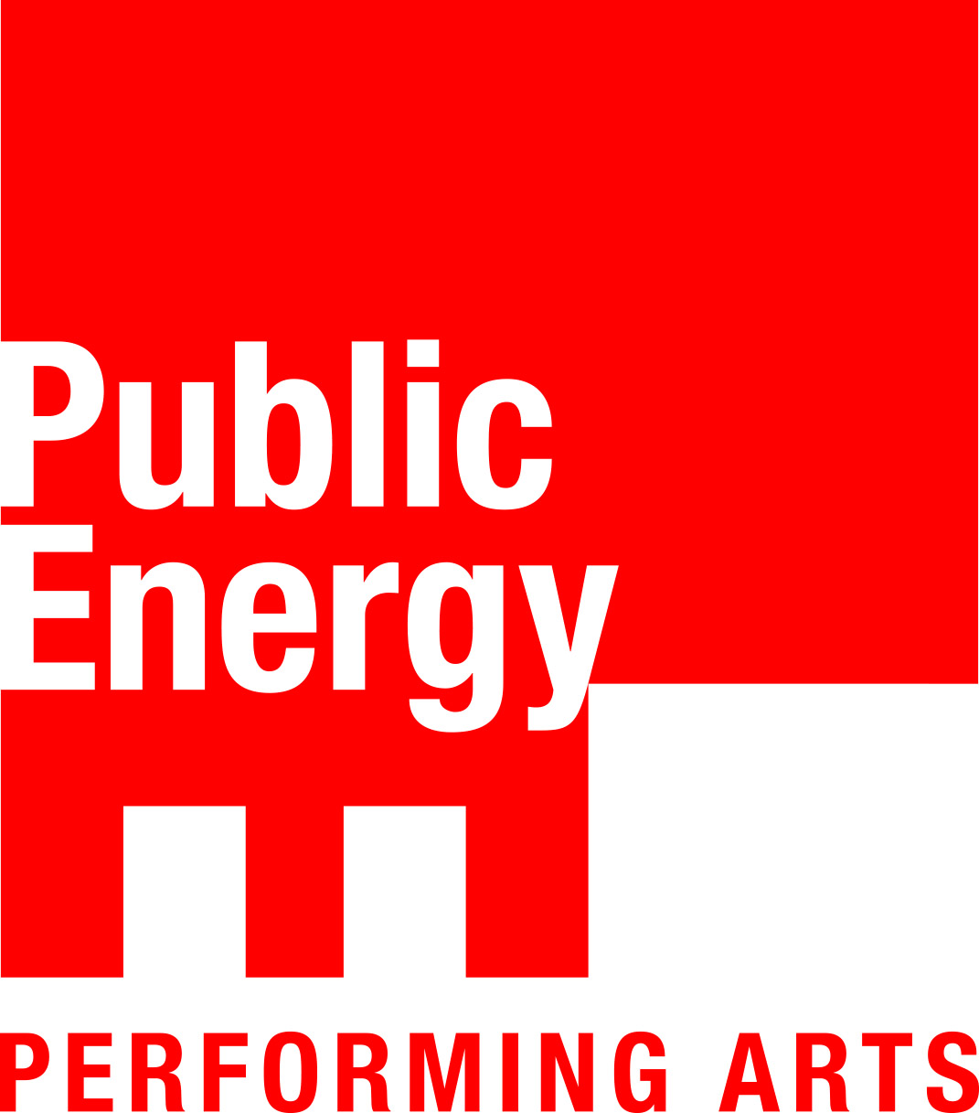 Public Energy Performing Arts

FOR IMMEDIATE RELEASE: March 16, 2020. For more information: Bill Kimball, bill@publicenergy.ca 705-745-1788.

Public Energy Performing Arts presents
Emergency Performance Festival #23
Friday, April 3 & Saturday April 4

Market Hall Performing Arts Centre, 140 Charlotte Street, Peterborough
The Theatre on King, 171 King Street, Peterborough
Tickets available at the Market Hall Box Office online or phone: 705-749-1146

“Emergency truly is a festival where there is something for everyone”
– kawarthaNOW.com

From experimental theatre to contemporary dance, the Emergency Festival – now in its 23rd year – showcases local Peterborough-area artists creating new work. The 2020 Emergency Festival #23 will feature work by vibrant artists: Hermione Rivison, Nadine Changfoot, Ann Jaeger, Dreda Blow, Iréni Stamou, Kristal Jones, Wes Ryan, and Paul Epstein.

From clowning, to dance, to physical theatre, to performance art, to spoken word poetry, this year’s Emergency Festival explores themes of ageism and ableism, passion and obsession, the natural world, mental health, identity and joy. Emergency Performance Festival #23 also features music by local songwriters and musicians including Tim Vespers and Bruno Merz.

“Because it showcases new work, the Emergency Festival is really exciting because it shows us what stories local artists are passionate about telling, whether it be through the language of dance, theatre, poetry or performance,” says Associate Director and Performance Curator, Victoria Mohr-Blakeney.

For over 20 years, Public Energy has made the Emergency Festival the cornerstone of its commitment to support local artists in the creation of new work. Executive Director Bill Kimball who founded the first Emergency Festival states: “It’s been amazing to see the artists that have performed on these stages in the Emergency Festival over the years. Many have gone on to full careers in performance other have founded theatres and teaching programs here in town. It’s phenomenal to see the impact the festival has had.”

Emergency Festival not only engages local audiences and artists, it also creates lasting collaborative partnerships with individuals and community groups. More than 200 local artists have premiered new works through Emergency; some of those have later developed into full-length performances and gone on to tour more widely. “The Emergency Festival has been a wonderful way to support local artists over the years – from the first performance until now – I can’t believe how excited this community and its artists have been to support this festival for over 20 years,” adds Kimball.

Emergency Festival artists applied via an open call for submissions in the fall of 2019. The jury selected to top applicants to perform in the festival based on the criteria of: strength of concept, clarity of description, feasibility of the process and presentation, and ability of the creator(s) and performer(s) to carry out the project. All performances had to be new work between 10-30 minutes in length, and artists had to reside in the Peterborough/Nogojiwanong area.

“It’s a powerful festival because it reminds us what’s possible when you have an idea, and a stage, and are ready to share it with the world,” adds Mohr-Blakeney.

"It’s a great pleasure to be able to explore my practice as a dance artist and share the stage with such a diverse range of creators in this year’s Emergency Festival. It’s a brilliant opportunity for artists to try things out, break new ground, and seek collaborations, then share their discoveries with such an encouraging, supportive community!" – Dreda Blow, Artist, Emergency Performance Festival #23

"Emergency has always been one of my favourite events for discovering truly original performance work in Peterborough. Now as a participating artist, I am thrilled to present A Song for Evermor, an interdisciplinary collaboration featuring the remarkable 2011 suite of music from Tin Vespers, animated with a kinetic set and performances by Kate Story and Ryan Kerr. Through programs like Alternating Currents and Emergency, Public Energy has provided invaluable support for this fledgling work that we hope will become a full production in the future." – Ann Jaeger, Artist, Emergency Performance Festival #23

SCheDULE:

PROGRAM A: THE THEATRE ON KING (50MINS)
Friday April 3rd at 8pm, Saturday April 4th at 2pm and 7pm

PROGRAM B: MARKET HALL (85 MINS INCLUDING 15 MIN INTERMISSION)
Saturday April 4th at 3:30pm and 8:30pm

Performances:

PROGRAM A: THE THEATRE ON KING
Program length: 50 minutes
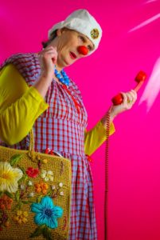
Photo: everybeauty.ca

GETTING MY MORDS WIXED
Artist: Hermione Rivison
Joy, the clown experiences the audacity of scammers, and the cheekiness that comes of being questioned by an ‘authoritative’ figure. Joy invites you to help her out as she meets these characters. She wants you to consider another perspective, she pulls out the humour and the gravity of situations that we face on a regular basis. There are no wrong answers but there may be ones that are more correct or useful to us.

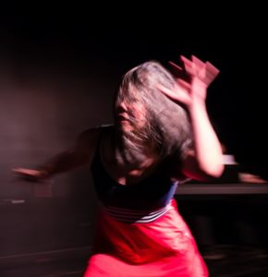
Photo: Andy Carroll

AGING, DISABILITY AND DIFFERENCE WORLD-MAKING
Artists: Nadine Changfoot, Mary Anne Ansley, Andrea Dodsworth (dancers-movers)
Mark Julson (accompanist)
Dreda Blow (outside eye)
In Aging, Disability and Difference World-Making, encounters of ableism and ageism that manifest in othering among three aging women living with diverse abilities and difference transform into affective connection and entanglements of collective and individual energies and possibilities.
We would like to thank Public Energy, The Theatre on King, Bodies in Translation: Activist Art, Technology, and Access to Life, and Studio 505 for their support!
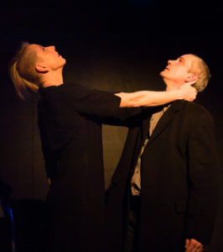
Photo: Andy Carroll

A SONG FOR EVERMOR
Concept and design by Ann Jaeger
Performance and choreography by Kate Story and Ryan Kerr
Music by Tin Vespers
Based on the 2011 musical suite of the same name by Tin Vespers, A Song for Evermor is inspired by the real life story of the largest free-standing scrap metal sculpture in the world and its eccentric creator, Tom Every with his alter ego, Dr. Evermor. It is a two fold love story about Dr. Evermor’s love for his wife, Lady Eleanor, and his passion, or perhaps obsession, for his creation.

PROGRAM B: MARKET HALL PERFORMING ARTS CENTRE
Program length: 85 minutes (including 15 minute intermission)
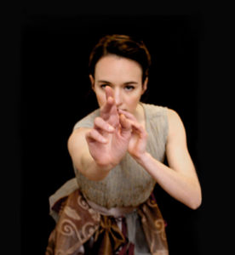
Photo: everybeauty.ca

LUNGS & LEAVES
Artist: Dreda Blow
Choreographed and danced by Dreda Blow, original musical score by Bruno Merz, song performed by Cormac Culkeen
Born from the earth, a creature is gifted with a fleeting, flickering moment to live. Inspired by the twisting, curving shapes and breaths of the natural world, this dance solo reflects on life’s cycles, so precious and vulnerable.

THE BOOK OF MILES: GENESIS
Artists: Paul Epstein, Lester Alfonso
Everything is a little out of reach for Miles, including identity, belonging, and his toothbrush. Physical Theatre artist Paul Epstein explores diaspora from the top of a ladder, and tragic history when it seems to be coming around again, and again, and again. Is it funny?

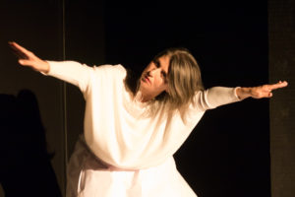
Photo: Andy Carroll

BONESTORIES
Artist: Iréni Stamou
Choreography: Irèni Stamou
Dancers: Irèni Stamou, Dreda Blow
Music: Youman
Bonestories comprises two solo dances, each emerging out of the other. A mythical ancestral call to protect nature and stop violence against women. Stories of spirit from deep within the bones and a glimpse into a larger choreography yet to come.
*While this performance did not go through the original call for submissions, after Emergency #23 saw the loss of one of the originally programmed works for this season, Irèni Stamou graciously offered to perform as a part of the festival having recently prepared this piece for the Small Dance for a Small Space Festival in February 2020.
Photo: Mark Craighead

FAT.GIRL.RIOT
Kristal Jones
Written/Performed by: Kristal Jones
Stage Direction/Mentor/Outside Eye: Diana Stephans
Lights and Projection: Mark L. Craighead
A Poetic Projection Performance. Local Artist Kristal Jones showcases a mosaic of her bodies of work spanning across photographic, poetic, and movement based mediums. This one-woman show celebrates the evolution of self love for a fat femme in her 30s, using humor, authenticity and powerful vulnerability. Kristal hope’s this piece leaves you filled with self compassion and feeling like you’ve been seen.
Content Advisory: This performance contains full or partial nudity.

THE CLARITY OF BRIGHTNESS
Wes Ryan
poetry by PJ Thomas
choreography by Wes Ryan
featuring: Caroline Barber, Kristen Hampson, Pat Lewis, Phil Lyons, and Mariya Yagnyukova
The Clarity of Brightness is an exploration of mental health, poetry, community, resilience, and the feminine. Told through poetry, dance, and theatre, this production features a cast of people with disabilities who each bring their own physicality and arts practice to the production. Each performer explores the physical while reciting verse, creating an atmosphere of verbatim dance. Set to the poetry of PJ Thomas and choreographed by Wes Ryan, The Clarity of Brightness invites audiences to peek into crevices of humanity often ignored by society.

TICKETS: Tickets are $15 general admission plus fees. All tickets are available from the Market Hall Box Office online at markethall.org, by phone 705-749-1146, or in person Monday to Friday from noon to 5pm.

Show and Season Sponsors and Funders
Show sponsors: Package Plus and Peterborough Inn and Suites
Major Season Sponsor: BMO Shepherd Wealth Management
Season Sponsors: Jo Pillon Royal LePage; Hi Ho Silver; kawarthaNOW; WE Design
Funders: Government of Canada through the Canada Council for the Arts and the Department of Canadian Heritage; Ontario Arts Council; City of Peterborough

